Ex. No. : 1 MITHRAN VT
240701312

Comparative Study of Low-Code Development
Aim
To study and compare low-code development with traditional software development, focusing on their development process, workflow, advantages, limitations, and technical differences.
Introduction
- Traditional software development involves writing code manually using programming languages and development tools. Developers are responsible for designing the application, creating databases, implementing features, testing, and deployment.

- Low-code development uses visual development environments, drag-and-drop components, pre-built features, and minimal coding to create applications. Platforms such as Zoho Creator make it possible to develop applications faster while reducing the amount of manual programming required.

Low-Code Application Development

- Traditional software development involves writing code manually using programming languages and development tools. Developers are responsible for designing the application, creating databases, implementing features, testing, and deployment.

- Low-code development uses visual development environments, drag-and-drop components, pre-built features, and minimal coding to create applications. Platforms such as Zoho Creator make it possible to develop applications faster while reducing the amount of manual programming required.

Traditional Application Development

Traditional application development is a conventional approach in which software is developed mainly through manual programming and coding. Developers use programming languages such as Java, Python, C++, or JavaScript along with development environments and other tools to build applications.

The process generally begins with requirement analysis, where the needs of the users and the system are identified. This is followed by system design, where the application architecture, database structure, user interface, and functionality are planned. Developers then write the required code and integrate different components of the application.

After implementation, the application goes through testing and debugging to identify and correct errors. Once the application is stable, it is deployed for users. Maintenance is then carried out to fix bugs, improve existing features, and add new functionality.
Traditional development provides high flexibility and complete control over the application's code, database, architecture, and functionality. However, it usually requires skilled developers and can involve greater development time, cost, and effort compared with low-code development.

Main stages:

- Requirement Analysis
- System Design
- Coding and Implementation
- Testing and Debugging
- Deployment
- Maintenance and Updates

Objectives:
The objectives of this study are:

- To understand the fundamental differences between the development lifecycles of low-code application development and traditional application development.
- To compare both approaches based on key parameters such as development speed, cost, skill requirements, flexibility, scalability, security, and maintenance.
- To evaluate the efficiency of the Zoho Creator low-code platform in developing business applications.
- To identify the types of business applications and use cases for which low-code and traditional development approaches are most suitable.
- To examine the advantages and limitations of adopting a low-code platform such as Zoho Creator compared with conventional software development methods.
- To provide recommendations that help organizations choose the most appropriate application development approach based on project complexity, available resources, and business requirements.

Development Lifecycle Comparison
- Traditional application development follows a sequential Software Development Life Cycle (SDLC), where each phase is completed separately before moving to the next.
- The development lifecycle describes the different stages followed to develop and maintain an application. Traditional development and low-code development follow similar overall stages, but the amount of manual coding and engineering effort differs significantly.
- Traditional Development Lifecycle:
Requirement Analysis → System Design → Coding → Testing → Deployment → Maintenance
- In traditional development, each stage requires considerable manual effort from developers. The database, application logic, user interface, testing, and deployment are generally handled using programming languages and development tools.
- Low-Code Development Lifecycle:
Requirement Analysis → Visual Design → Configuration → Testing → Deployment → Maintenance
- In low-code development, many development activities are simplified through visual interfaces, drag-and-drop components, pre-built modules, and configuration-based workflows. This reduces the amount of manual programming required.

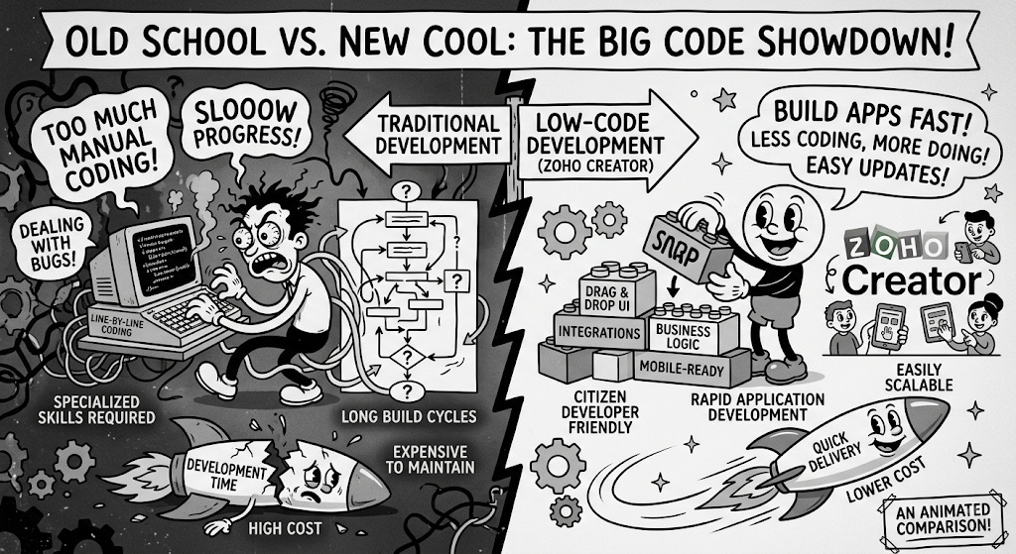
Daily Example

Consider a healthcare organization that requires an internal Hotel booking and customer confirmation application.

Using Zoho Creator (Low-Code Development)
- Traditional application development involves building an application through manual coding and conventional software development tools. Developers write the required program code, design the database, create the user interface, integrate different components, and manage the application throughout its development lifecycle.
- The development process generally includes requirement analysis, system design, coding, testing, deployment, and maintenance. Each stage requires technical knowledge and direct involvement from developers.
- Traditional development provides complete control and flexibility over the application's functionality, architecture, database, and user interface. It is suitable for complex applications that require highly customized features and performance. However, it usually requires more development time, skilled programmers, and maintenance effort compared with low-code development.

Using Traditional Application Development

Traditional application development is carried out by writing program code manually using programming languages and standard development tools. Developers are responsible for designing the application, creating the database, implementing the required functions, testing the system, and deploying the final application.
This approach provides complete control over the application's code, architecture, and functionality. It is suitable for applications that require complex features and extensive customization. However, traditional development generally requires more time, skilled developers, higher development effort, and detailed testing and maintenance.

Advantages of Traditional Application Development
- High Customization – Developers have complete control over the application's features, design, and functionality.
- Complete Code Control – Developers can modify and manage every part of the source code.
- Better Flexibility – The application can be designed according to specific business or technical requirements.
- Suitable for Complex Systems – It is suitable for complex, high-performance, and highly customized applications.
- No Vendor Lock-in – The organization owns the source code and is not dependent on a particular low-code platform.

Limitations of Traditional Application Development
- Time-Consuming – Applications take longer to develop because most features are coded manually.
- Higher Cost – It requires skilled developers, development resources, and long-term maintenance.
- Requires Technical Expertise – Developers need strong programming and software-development knowledge.
- Complex Maintenance – Bug fixes and updates generally require manual coding and testing.
- More Development Effort – Database creation, application logic, testing, and deployment require greater engineering effort.

Advantages of Low-Code Application Development
- Faster Development – Applications can be developed quickly using pre-built components.
- Less Coding – Reduces the amount of manual programming required.
- Easy to Use – Visual interfaces make application development easier for users with limited programming knowledge.
- Lower Initial Cost – Reduces development effort and the need for extensive programming resources.
- Easy Maintenance – Changes and updates can be made through visual configuration and centralized platform features.

Limitations of Low-Code Application Development
- Limited Customization – Customization may be restricted by the features provided by the platform.
- Vendor Lock-in – Applications become dependent on the selected low-code platform and its ecosystem.
- Platform Dependency – The application's functionality can depend on the platform's available tools and services.
- Recurring Costs – Low-code platforms may involve licensing or subscription fees.
- Less Control – Developers have less direct control over the underlying code and system architecture compared with traditional development.

Result

The comparative study of traditional application development and low-code application development was successfully completed. Traditional development provides greater control and customization but requires more time, technical expertise, and development effort. Low-code development simplifies the process through visual tools and pre-built components, enabling faster application development with less manual coding.

Conclusion

The study concludes that traditional application development provides greater flexibility, customization, and control but requires more time, technical expertise, and development effort. Low-code application development simplifies the development process through visual tools and pre-built components, enabling faster and easier application creation with less manual coding. Therefore, low-code platforms are suitable for rapid application development, while traditional development is more appropriate for complex and highly customized systems.

